Smyrna Elementary
PTA Board Meeting
Monday August 6, 2018

- Called to Order @ 6:33pm

- Reviewed Mission Statement, Goals and Inspiration

Inspiration- Tiffany: involvement of all hands-on deck first few days- Arduino wiping tables, husband/wife team volunteered all 3 days of lunches

- Read and approved prior meeting’s minutes- Courtney moved to approve – All In agreement

- Reports of Officers
  - Principal’s Report (Sharon Arduino)-
    - Total enrollment: 1002
    - Class avg:
    - K: 21
    - 1st: 20
    - 2nd: 20
    - 3rd: 20
    - 4th: 25
    - 5th: 25

  - Co-President’s Report (Jenn Simms & Andrea Blanton)
    - Membership @494, few staff members have not signed up, need 524 to meet state goal
  - Treasurer’s Report (Jennifer Moss)-
    - will email finalized proposed budget, a lot of activity on account between spirit wear orders and sponsors coming in
  - Teacher Liaison’s Report (Bailey Oliver)-
    - 9/17: Mass Hearing/Vision for 1st and 4th and 8/13-14: Mobile Eye Clinic, need parent volunteers
    - Carpool- most of carpool line is city streets- signage would have to go through GDOT and we would have to pay, OPTIONS: Campbell HS resource officers, hire off-duty officers $125/hr, potentially look for donations to pay for police presence, Parents/Staff need to call and ask for police presence, may send out information about how to use round-about, cars cannot be in bus port when buses are entering/exiting, possible shift change in crossing guard hours, get police or firefighters to come give suggestions on traffic flow
  - VP Communication Report (Tiffany Sudderth)-
    - Open House Info: call out will go out, Bailey will do stickers for Open House
    - Working on flyer to show where to get information, translations need to be done locally at the school
    - Post updated sponsorship packages
    - Would like to see school-wide weekly call outs continued
  - VP Development Report (Angela San Martin)
    - Derrick Norton (City Council) joined online, need to send credit card info for online requests to join
    - $8800 in sponsorships, Vinings School of Art potential sponsor, Google Document with Foundation updating sponsorships
    - Smyrna Education Foundation (Susan Thayer)- need to find out how to benefit from this
    - Partners in Education- we’ve had 8 total, Arduino will send list
    - 6 Sponsor Booths at Open House
  - VP Parental Involvement Report (Courtney Grant w Maria Pedroza)-
    - many volunteer forms returned, will send list of committee chairs
  - Secretary Report (Kristen Cranford)-
    - Membership list is in progress
    - Need list of sponsorships to update list- Angela will email
    - Dress Down Day Money collection- will email sign up, need more than 2 people each day, March date changed from 8th to 15th

- Report of Committees
  - None tonight will be established

- Tabled Business: N/A
- New Business:
  - Principal Account- need donations, PTA will have 1 dress down day (8/10) goes towards it and will ask the same of Foundation, PJ Day (11/5), Possible Penny War beginning of calendar year
  - October Month PTA celebration (LGBTQ history)- We will celebrate acceptance- family units look different
  - Spirit Wear (socks, more teacher shirts) Approval of socks
  - Carpool/ afternoon dismissal- discussion above
  - Membership totals (494)
  - Budget for 18/19 final approval before general meeting

- Announcements:
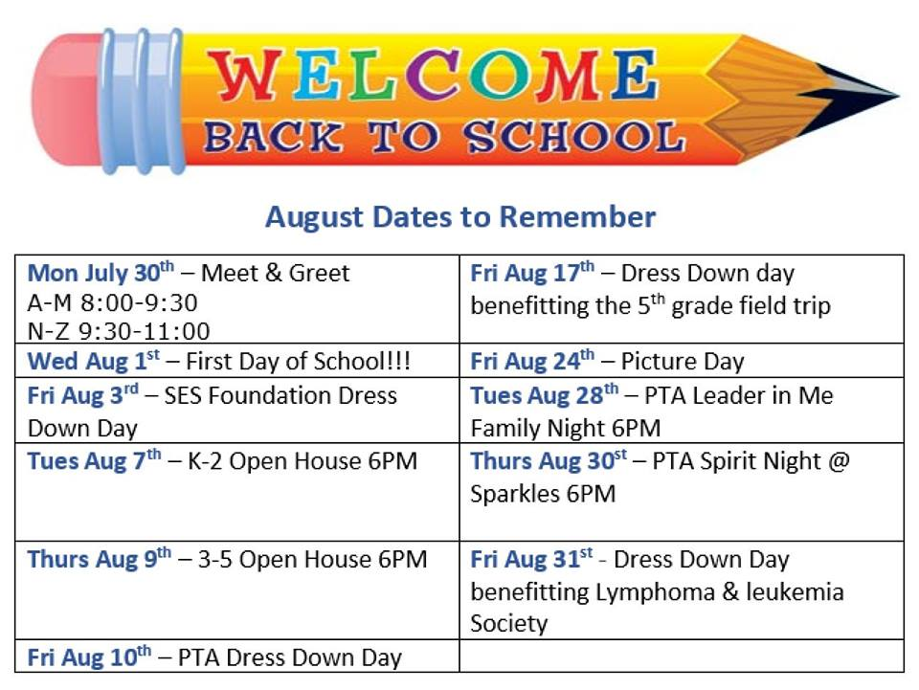
- Meeting Adjourned @ 8:36pm
Date for Next PTA Board Meeting, September 10, 6:30 PM

